Key Issue 1: Where Are Folk and Popular Leisure Activities Distributed?
Pages 108-115

***Always keep your key term packet out whenever you take notes from Rubenstein. As the terms come up in the text, think through the significance of the term.
*Use page 108 to answer #1 and #2
- Define folk culture:

- Define popular culture:

- What is the difference between a habit and a custom and provide an example of each?

- Complete the following table comparing and contrasting the origins, diffusion, and distribution of folk and popular culture .
 | Origins | Diffusion | Distribution
Folk Culture
Popular Culture

- List the elements of the origin and characteristics of folk music.

- List the elements of the origin and diffusion of popular music.

- List the elements of the origin and diffusion of soccer. Be sure to discuss the connection to folk and popular culture.

- Label popular sports with the countries in which they are the most popular.
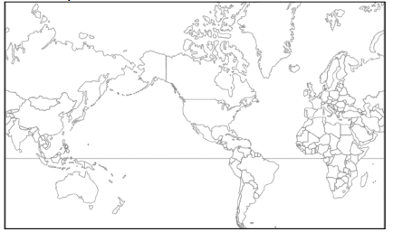

Key Issue 2: Where Are Folk and Popular Material Culture Distributed?
Pages 116-125

- In Western countries where popular culture predominates, clothing styles generally reflect ________________ rather than particular ________________________.

- How does clothing style (in this case shoes) indicate the influence of the environment on folk culture?

- Can you think of other restrictions on clothing styles in developed countries, perhaps in schools?

- What are three facts about clothing styles associated with popular culture?
- Food preferences are strongly influenced by ______________________________________.

- List three different examples of food habits and the unique folk cultures each illustrates.

- Indicate some food taboos, along with the cultures that practice them, in the chart below.

Food Taboos
Cultures/Regions | Foods/Reasons

- Consumption of large quantities of snack foods and alcoholic beverages are characteristic of popular culture. Explain how each of these food preferences are expressed regionally, according to culture.

- Do your food preferences match the predominant ones in your region?

- In what sense are building materials of folk housing unique?

- Give three examples of how religious values or belies may influence folk housing.

- Fred Kniffen, a cultural geographer, has identified three source regions for American folk housing styles: New England, Middle Atlantic and Lower Chesapeake. List the housing styles he identified with each region.
  - New England (4 styles) –

  - Middle Atlantic (1 dominant style) –

  - Lower Chesapeake –

- Complete the chart below to indicate the decade(s) during which each housing style was dominant and a fact about the particular style of house.

Style | Decades(s) | Facts
Minimal
Traditional
Ranch House
Split-Level
Contemporary
Style
Shed Style

- What are the Neo-eclectic styles of the 1960’s and 1970’s?

Key Issue 3: Why is Access to Folk and Popular Culture Unequal?
Pages 126-131

- Give two reasons for which television is an especially significant element of culture.

- Using the 2005 map in Figure 4-28 on page 126, complete the following chart about television access
Television is Universal | Television is Common | Television is Rare

- Using the maps on page 128:
  - In 2011, where was the Internet most widely available?

  - In what regions, then, are there populations still relatively untouched by the Internet?

- What three countries dominate worldwide television markets?

- Why do developing nations view television as a new source of cultural imperialism?

- What are the world’s two largest newspaper organizations? What countries are they associated with?

Key Issue 4: Why Do Folk and Popular Culture Face Sustainability Problems?
Pages 132-137

- Where did Amish culture originate, and how did it diffuse to the United States?

- What is happening to the Amish in the United States today?

- Label and shade the areas of larger Amish settlements in the U.S. (Use Figure 4-39 on page 132).

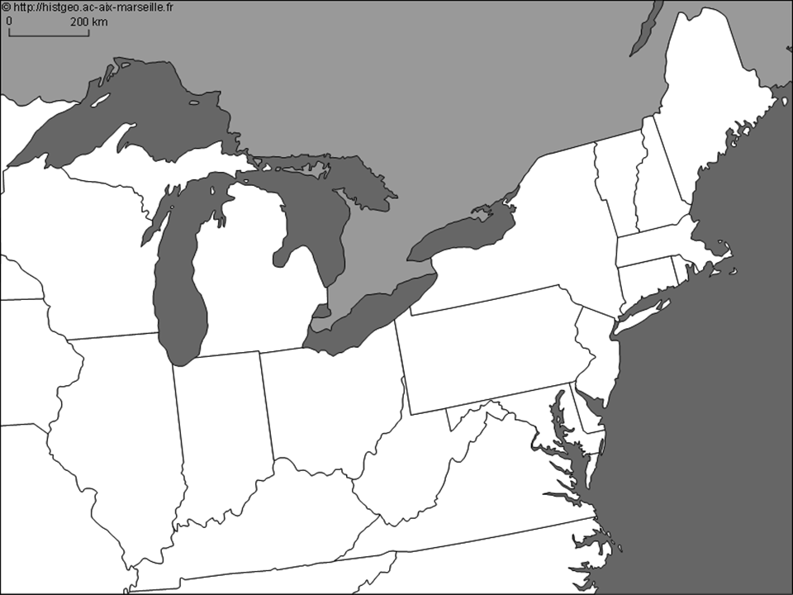

- How has global diffusion of popular social customs had an unintended negative impact on women in India?

- What are the two ways in which popular customs have an adverse effect on the natural environment?

- What is a uniform landscape?

- How and why is this concept utilized by fast-food restaurants?

- How is the playing of golf and golf courses an example of a popular custom that is not generally in harmony with the local environment?

- Summarize major sources of waste and how each is recycled (make a chart and/or bulleted list)

