Buddhism
Dalai Lama  (B) | Tibetan Buddhism  (B)
Mahayana  (B) | Largest % located in China, Japan and Korea  (M)
Vajrayana  (B) | Tibet & Mongolia  (V)
Theravada  (B) | Second largest, located in Cambodia, Laos, Myanmar, Sri Lanka & Thailand  (T)

Siddhartha Gautama  (B) | Born in Nepal  (SG)
Lived in a forest  (SG) | 4 Noble Truths  (B)
All must endure suffering  (4NT) | Suffering leads to reincarnation  (4NT)
Goal is to escape endless cycle & reach Nirvana  (4NT) | Can achieve Nirvana through the Eightfold Path  (4NT)
Means “the way of the elders”  (T) | Older of the two largest branches of Buddhism  (T)
To become a good Buddhist you must become a monk  (T) | Less demanding and more encompassing  (M)
Split from Theravada 2000 years ago  (M) | Focus on helping others, compassion  (M)
Focus on Buddha’s wisdom  (T) | Practice of Tantras  (V)

Christianity | Roman Catholic  (C)
Protestant  (C) | Orthodox  (C)
Mathew, Mark, Luke & John  (C) | The Last Supper  (C)
Pope  (RC) | 7 sacraments  (RC)

also called Eastern Orthodox  (O) | split from the Roman Catholic Church in the 5th century  (O)
Reformation  (P) | Martin Luther  (P)
95 Thesis  (P) | Grace received through faith rather than sacraments  (P)
Islam | Universalizing
5 pillars of faith  (I) | Hajj  (I)
Pray 5 times daily  (I) | Ramadan  (I)
Adam was the first man  (I, C, J) | Trace their story through Isaac  (J,C))
Trace their story through Ismael  (I) | Prophet Muhammad  (I)

Makkah  (Mecca)  (I) | Madinah (Medina)  (I)
Shiites  (I) | Sunnis  (I)
caliph  (I) | “Successor of the prophet”  (Caliph)
Largest branch in Islam  (Sunni) | Smaller of the two branches in Islam  (Shiite)
shah  (I) | “king”  (shah)
ayatollah  (I) | “Religious leader”  (ayatollah)
Believe they’re descendants of Muhammad  (Shia Islam) | Believe they chose a more acceptable leader, but was not a descendant of Muhammad  (Sunni Islam)
Sikhism | Guru Nanak  (S)
Sikhs  (U) | Hindi word for “disciples”  (Sikhs)
The Holy Granth of Enlightenment  (S) | Baha’i  (U)
Established in Iran in the 19th century  (Bah) | Hinduism
No specific founder  (H) | Began before recorded history  (H)
Associated with the Caste System  (H) | Hearth is near present day Israel  (C)
First diffused from Judea through relocation diffusion  (C) | Originates near/in present day Mecca/Medina  (I)
Originates in northeastern India  (B) | Asoka  (B)
Romans forced Jews to move throughout the world  (diaspora) | Diaspora  (J)
ghettos  (J) | Mosque  (I)
Pagoda  (B) | 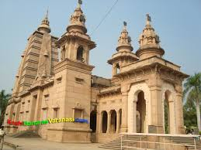  (B)
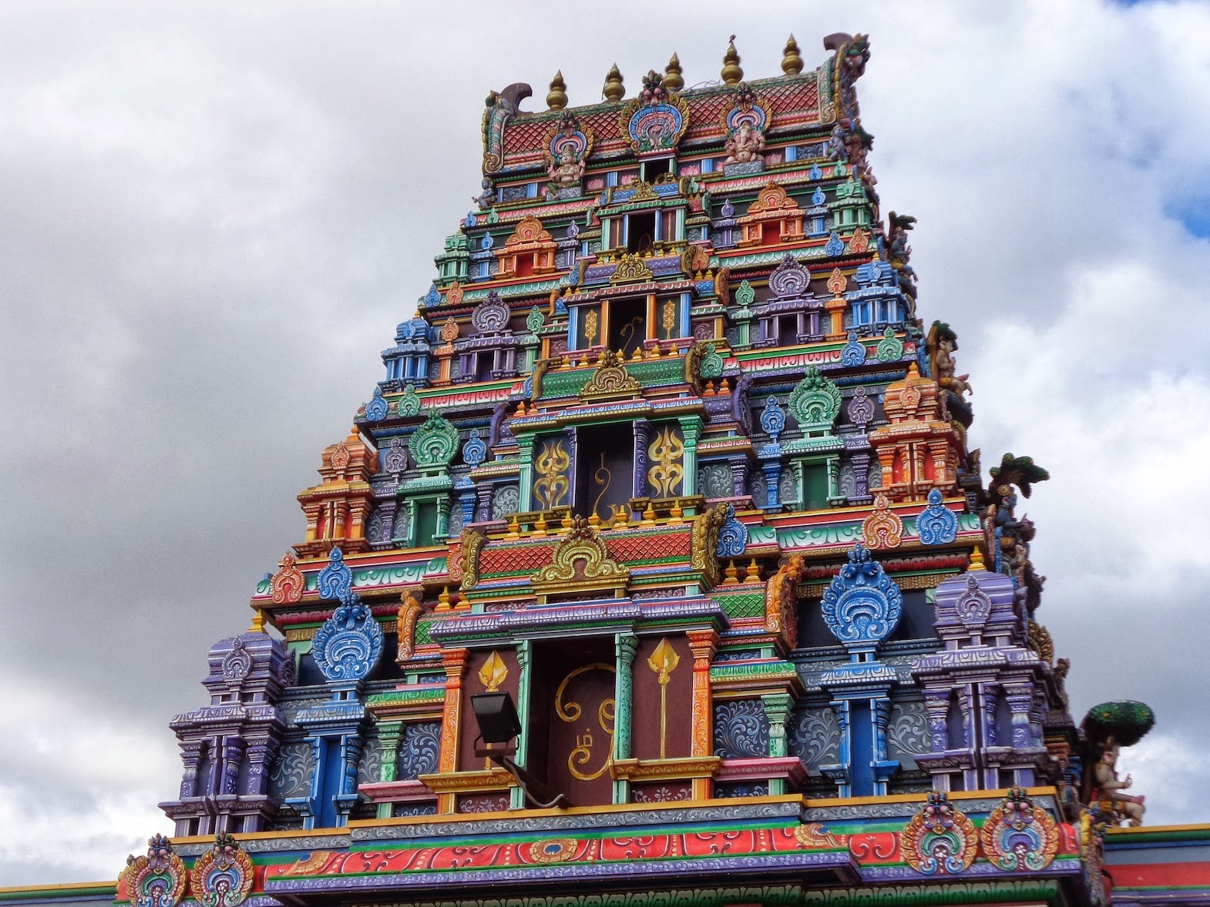  (H) | Hindu Temple
Dome of the Rock | 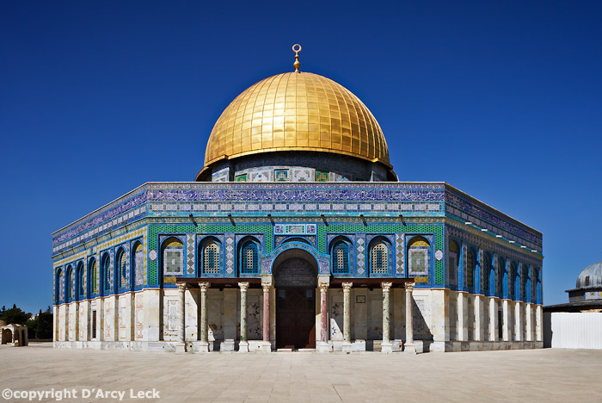
Kaaba (Ka’ba)  (I) | 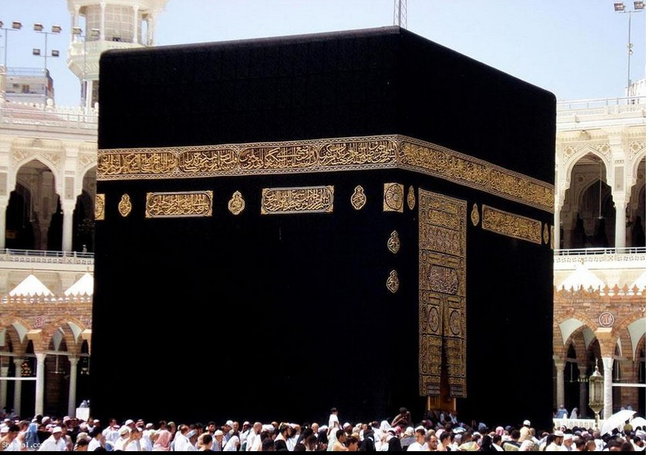
Golden Temple  (S) | 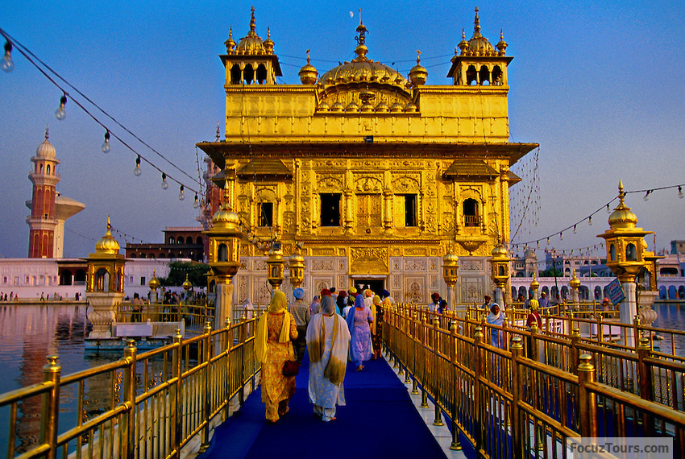
Holiest city in Islam  (Mecca) | Second holiest city in Islam  (Medina)
Pilgrimage to Mecca  (I) | Ganges River  (H)
Holiest River in Hindu faith  (H) | Cosmogony (V)
Set of religious beliefs concerned with the origins of the universe  (V) | Yin/yang  (Con/Tao)
Utopian Settlement | Bethlehem, Pennsylvania
Joseph Smith | Mormon
Atheism (V) | Belief that God does not exist (V)
Agnosticism (V) | Belief that nothing can be known about whether their truly is a God. (V)
Syncretic (V) | Religion that combines several traditions (V)
Creole (V) | Language that results from the mixing of a colonizer’s language w/the ppl being dominated (V)
Franglais (V) | Term used by the French for English words that have entered the French language (V)
Denglish (V) | Combo of German and English (V)
Logogram (V) | A symbol that represents a word rather than a sound  (V)
Pidgin Language (V) | Form of speech that adopts a simplified grammar and limited vocab of a lingua franca; used to communicate between two diff. languages (V)
Spanglish (V) | Combo of Spanish and English (V)
Vulgar Latin (V) | Form of Latin used by ancient Romans as opposed to the standard dialect used on official documents  (V)
Official language  (V) | Language adopted for use by the government to conduct business and for use in documents.  (V)
Standard language (V) | For of language used for official govt. business, education and mass communications (V)

