Name___________________________class________
Date______________________

Unit 2 Human Systems Review
Turn this in completed on test day for 5 bonus points!!!

- Explain the following terms and give examples:
  - Cultural diffusion:

  - Cultural Hearth:

  - Innovation:

  - Acculturation:

  - Culture:

- Explain the following terms and give examples:
  - Nation:

  - State:

  - Nation-State:

  - Stateless Nation:

- Physical geography plays a big role in where people choose to live. What types of environments tend to be the most highly populated?

- Explain the following terms:
  - Subsistence agriculture:

  - Cottage industry:

  - Commercial Agriculture:

  - Commercial Industry:

- Which is more likely to be seen in a developed country subsistence or commercial agriculture and why?

- Why is the population in the world growing?

- Explain the following levels of economic activity and give examples:
  - Primary:

  - Secondary:
  - Tertiary:

  - Quaternary:

- What are population pyramids? What do they show?

- Sketch and explain the 4 stages of population pyramids:
  - Stage 1:

  - Stage 2:

  - Stage 3:

  - Stage 4:

- Which stage of population pyramid is considered the least developed?

- Which stage of population pyramid is going through a population boom?

- Which stage of population pyramid is considered the most developed?

- Explain the following terms and give examples:
  - Renewable Resource:

  - Non-renewable Resource:

  - Inexhaustible Resource:

- What is a natural resource? How are they distributed around the planet?

- What is an ethnic group?

- Explain the following forms of government:
  - Democracy:

  - Monarchy:

  - Dictatorship:

  - Communism:

  - Theocracy:

- What are the characteristics of a developed state?

- What are the characteristics of a developing state?

- What are the characteristics of an underdeveloped state?

- Explain the following types of economic systems:
  - Free Market:

  - Command:

  - Mixed/Socialist:

  - Traditional:

- What is infrastructure? Why is in important and necessary for an economy to be successful?

 | Judaism | Christianity | Islam | Hinduism | Buddhism | Sikhism
Place of Origin
Holy Book/Teaching
Founder
Place of Worship
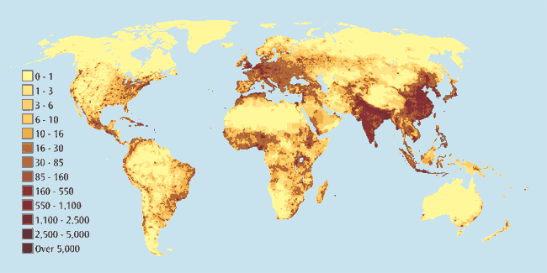

- Based on what you see in the population map and your knowledge of geography, what connections can you make between physical geography and population distribution? (Answer in a paragraph).

- Explain the difference between push and pull factors (Answer in a paragraph).

- How can culture work as both a uniting force and a dividing one? (Answer in a paragraph).

- What is the population paradox? (Answer in a paragraph).

