World Religion Comparison Chart Name:
- Go to the website: http://www.bbc.co.uk/religion/religions/
- Click on the religion’s name to find the most information.
 | Buddhism | Christianity | Hinduism | Islam | Judaism | Sikhism
Symbol
Year Began
Main Figures/Who Started?

What do they believe/Main Teachings

How many are there today?
Where do they live/location in the world? What’s the place of worship called?
What are the different sects/groups?
What do they believe about the afterlife?
What are their important rituals/ festivals?
What are their sacred texts?

What does your textbook and Rubenstein handout write about the above religions that the website did not say?
 | Buddhism | Christianity | Hinduism | Islam | Judaism | Sikhism

Ethel Wood

Rubenstein

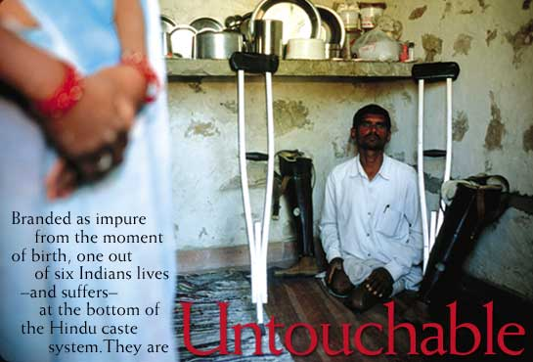
By Tom O'NeillPhotographs by William Albert Allard
Discrimination against India's lowest Hindu castes is technically illegal. But try telling that to the 160 million Untouchables, who face violent reprisals if they forget their place.
Get a taste of what awaits you in print from this compelling excerpt.
The sins of Girdharilal Maurya are many, his attackers insisted. He has bad karma. Why else would he, like his ancestors, be born an Untouchable, if not to pay for his past lives? Look, he is a leatherworker, and Hindu law says that working with animal skins makes him unclean, someone to avoid and revile. And his unseemly prosperity is a sin. Who does this Untouchable think he is, buying a small plot of land outside the village? Then he dared speak up, to the police and other authorities, demanding to use the new village well. He got what Untouchables deserve.
One night, while Maurya was away in a nearby city, eight men from the higher Rajput caste came to his farm. They broke his fences, stole his tractor, beat his wife and daughter, and burned down his house. The message was clear: Stay at the bottom where you belong.
* * * * * *
To be born a Hindu in India is to enter the caste system, one of the world's longest surviving forms of social stratification. Embedded in Indian culture for the past 1,500 years, the caste system follows a basic precept: All men are created unequal. The ranks in Hindu society come from a legend in which the main groupings, or varnas, emerge from a primordial being. From the mouth come the Brahmans—the priests and teachers. From the arms come the Kshatriyas—the rulers and soldiers. From the thighs come the Vaisyas—merchants and traders. From the feet come the Sudras—laborers. Each varna in turn contains hundreds of hereditary castes and subcastes with their own pecking orders.
A fifth group describes the people who are achuta, or untouchable. The primordial being does not claim them. Untouchables are outcasts—people considered too impure, too polluted, to rank as worthy beings. Prejudice defines their lives, particularly in the rural areas, where nearly three-quarters of India's people live. Untouchables are shunned, insulted, banned from temples and higher caste homes, made to eat and drink from separate utensils in public places, and, in extreme but not uncommon cases, are raped, burned, lynched, and gunned down.
******************************************On the back of this page**********************************************
Respond: Reflect on your reactions to this article. What does it make you think or feel? What are you left wondering? What questions do you now have? What will you take away from this article?
_______________________________________________________________________________________________________________________________________________________________________________________________________________________________________________________________________________________________________________________________________________________________________________________________________________________________________________________________________________________________________________________________________________________________________________________________________________________________________________________________________________________________________________________________________________________________________________________________________________________________________________________________________________________________________________________________________________________________________________________________________________________________________________________________________________________________________________________________________________________________________________________________________________________________________________________________________________________________________________________________________________________________________________________________________________________________________________________________________________________________________________________________________________________________________________________________________________________________________________________________________________________________________________________________________________________________________________________________________________________________________________________________________________________________________________________________________________________________________________________________________________________________________________________________________________________________________________________
_______________________________________________________________________________________________________________________________________________________________________________________________________________________________________________________________________________________________________________________________________________________________________________________________________________________________________________________________________________________________________________________________________________________________________________________________________________________________________________________________________________________________________________________________________________________________________________________________________________________________________________________________________________________________________________________________________________________________________________________________________________________________________________________________________________________________________________________________________________________________________________________________________________________________________________

Watch the History of Religion timeline video by clicking the link below and answer the following questions:
http://www.mapsofwar.com/ind/history-of-religion.html

- What is Jewish diaspora?
- What does Reconquista mean?
- Which is the oldest religion?

Use pages 184-185 in your textbook to recreate the religions distribution map on your own world map handout.
For each regional pie chart listed – list on your map(in the appropriate region) the 2 most dominant religion. If there is one religion that dominants the region make note that the second dominant religion is much less so. (in other words, use percentages to make the distinction.)

